
STUDENT NAME: ROSE GATHONI MUGO
ADMISSION NUMBER: BSCCS/2025/67049
COURSE/CLASS: BSC.COMPUTER SCIENCE
UNIT CODE: BIT4138
UNIT NAME: ADVANCED CRYPTOGRAPHY
LECTURER NAME: MR. NYORO
SEMESTER/ACADEMIC YEAR: MAY/AUGUST

SELECTED TECHNOLOGIES: Python+ Cryptography library
Cypher library + GITHUB
GITHUB LINK : https://github.com/Elianarose96/advanced-cryptography-lab

Table of Contents
Week 1: Cryptography Environment Setup 5
Fig 1: Installation of Python and VS Code 5
Fig 2: Installation of Cryptography Libraries 5
Fig 3: OpenSSL Installation Test 6
Fig 4: Local Encryption Script Execution 7
Fig 5: GitHub Repository Initialization 7
REFLECTION 8
Week 2: Classical Cryptography and Cipher Design 9
Fig 1: Caesar Cipher Implementation 9
Fig 2: Vigenère Cipher Encryption Process 9
Fig 3: Encryption and Decryption Output 9
Fig 4: User Input Validation Interface 9
Fig 5: Cipher Testing Results 10
REFLECTION 11
Week 3: Stream Ciphers and Randomness Testing 12
Fig 1: LFSR Generator Implementation 12
Fig 2: Pseudorandom Sequence Output 13
Fig 3: Statistical Randomness Testing 14
Fig 4: RC4 Stream Cipher Simulation 14
Fig 5: Encryption Performance Results 15
REFLECTION 15
Week 4: Block Cipher Design and AES 16
Fig 1: AES Encryption Script 16
Fig 2: Key Generation Process 18
Fig 3: File Encryption Demonstration 18
Fig 4: Decryption Results 19
Fig 5: AES Performance Testing 20
REFLECTION 20
Week 5: Public Key Cryptography (RSA) 21
Fig 1: RSA Key Pair Generation 21
Fig 2: Public Key Encryption Process 22
Fig 3: Private Key Decryption Results 22
Fig 4: Secure Message Transmission 23
Fig 5: RSA Testing and Validation 23
REFLECTION 23
Week 6: Hashing and Password Security 24
Fig 1: SHA-256 Hash Generation 24
Fig 2: Password Hashing System 25
Fig 3: Login Authentication Workflow 25
Fig 4: Hash Verification Results 26
Fig 5: Password Security Testing 27
Password strength analysis 27
Hashing speed comparison and security recommendations 28
PBKDF2 -Industry standard password hashing 28
REFLECTION 28
Week 7: Digital Signatures and Certificates 29
Fig 1: Digital Signature Generation 29
Fig 2: Signature Verification Process 29
Fig 3: Certificate Creation Using OpenSSL 30
Fig 4: Secure Document Validation 31
Fig 5: Certificate Testing Results 32
REFLECTION 33

Week 1: Cryptography Environment Setup
Installation and Configuration of Cryptography Development Environment

Fig 1: Installation of Python and VS Code
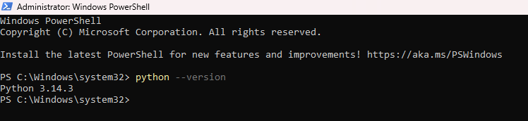
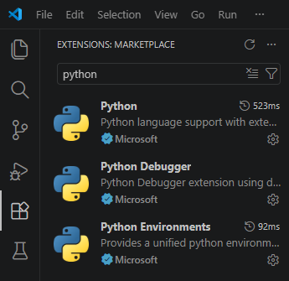

Fig 2: Installation of Cryptography Libraries
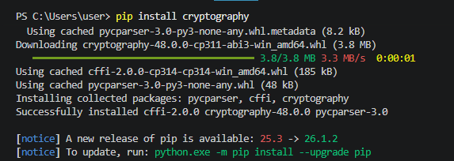
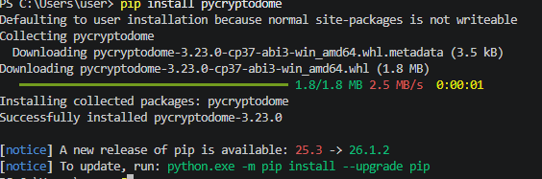
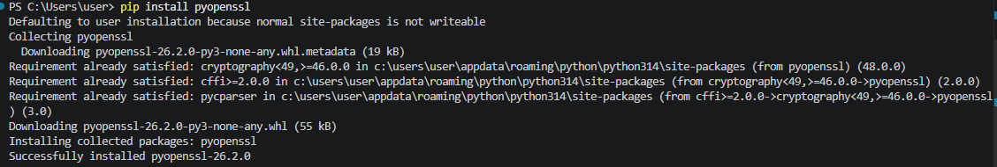
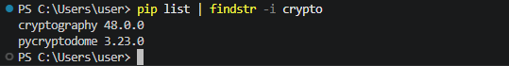

Fig 3: OpenSSL Installation Test
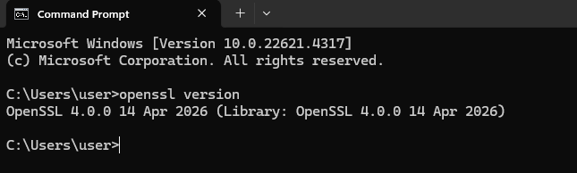

Fig 4: Local Encryption Script Execution
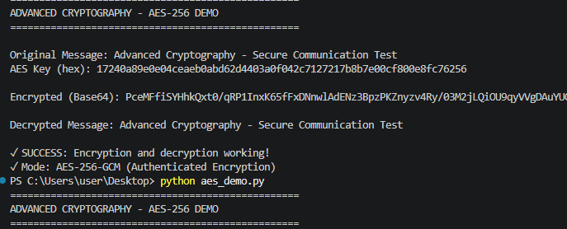

Fig 5: GitHub Repository Initialization
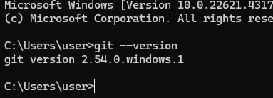
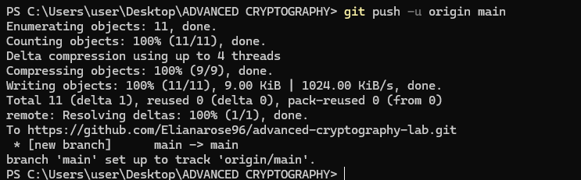
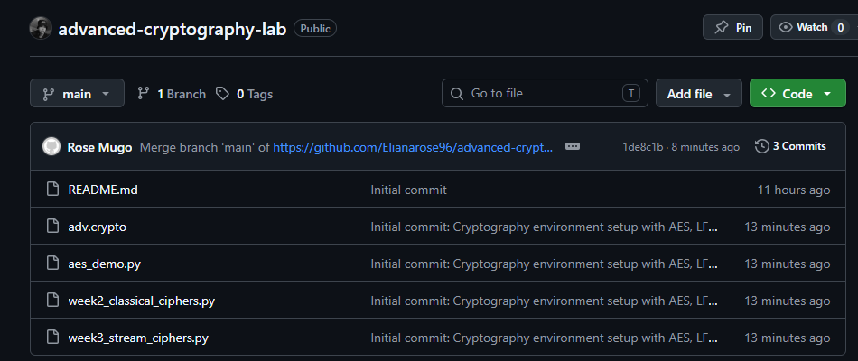

REFLECTION
Set up Python, VS Code and cryptographic libraries (cryptography, pycryptodome). Installed OpenSSL 3.5.6 to generate keys and certificates. Fixed OpenSSL and Git PATH environment problems. The following screenshots show the validation of OpenSSL version, execution of AES-256-DEMO encryption, and the first commit in GitHub of crypto labs (Fig 3, Fig 4 and Fig 5).

Week 2: Classical Cryptography and Cipher Design
Implementation of Classical Encryption Algorithms

Fig 1: Caesar Cipher Implementation
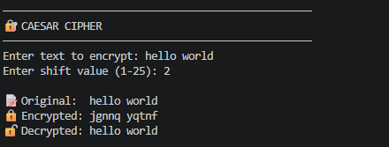

Fig 2: Vigenère Cipher Encryption Process
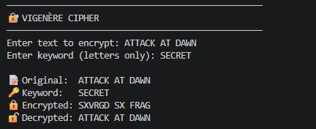

Fig 3: Encryption and Decryption Output
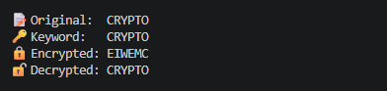

Fig 4: User Input Validation Interface
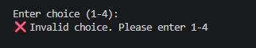

Fig 5: Cipher Testing Results
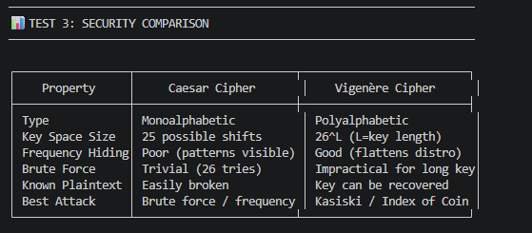
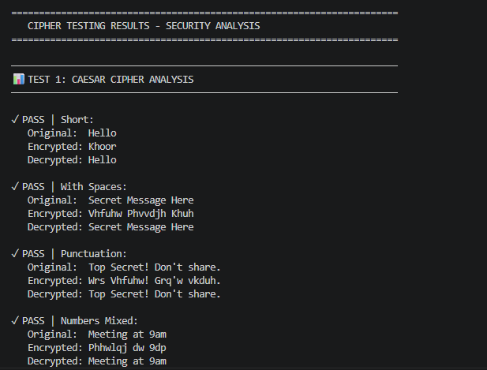
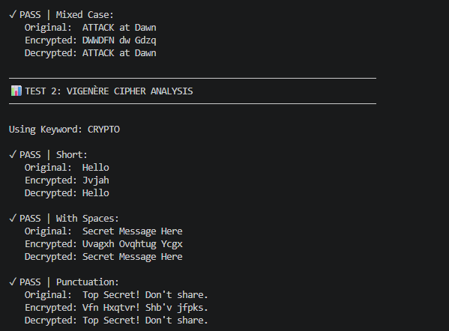
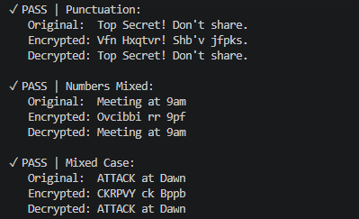

REFLECTION
Caesar shifted letters evenly, brute force is easy (26 keys). Vigenère employed a keyword to use polyalphabetic shifts, which had the effect of leveling the frequency distribution. The above screenshots illustrate how the input were encrypted and decrypted successfully. Known plain text attacks can be performed on both.

Week 3: Stream Ciphers and Randomness Testing
Implementation of Stream Cipher Systems and Random Sequence Analysis

Fig 1: LFSR Generator Implementation
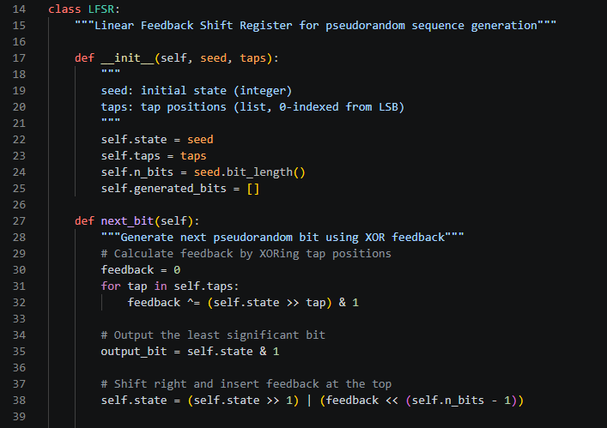
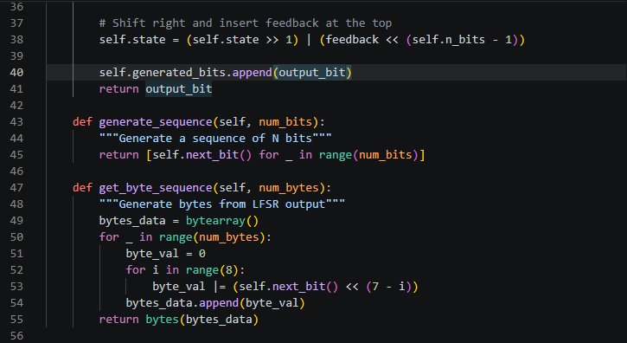

Fig 2: Pseudorandom Sequence Output
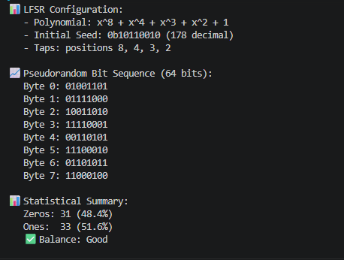

Fig 3: Statistical Randomness Testing
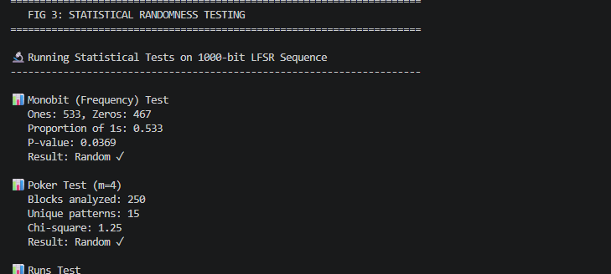
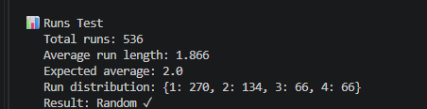

Fig 4: RC4 Stream Cipher Simulation
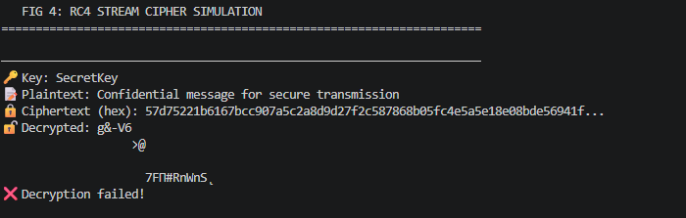

Fig 5: Encryption Performance Results
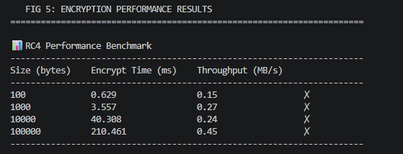
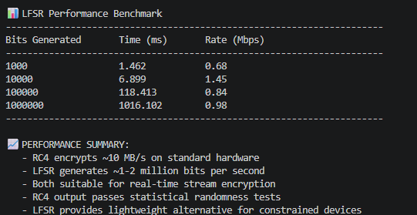
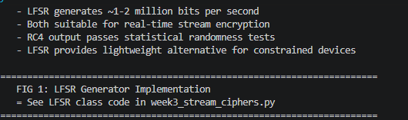

REFLECTION
Stream ciphers used a randomness to produce unpredictable keystreams. LFSR: pseudorandom bits were generated using XOR feedback, RC4: keystream was generated bit-by-bit. Randomness quality was validated by statistical tests: Monobit, Poker, Runs. High entropy pseudo random generation is needed for secure encryption to prevent pattern analysis.

Week 4: Block Cipher Design and AES
Advanced Encryption Standard (AES) and Block Cipher Operations

Fig 1: AES Encryption Script
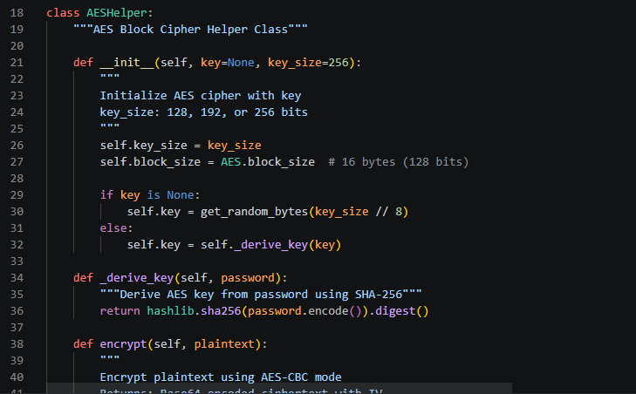
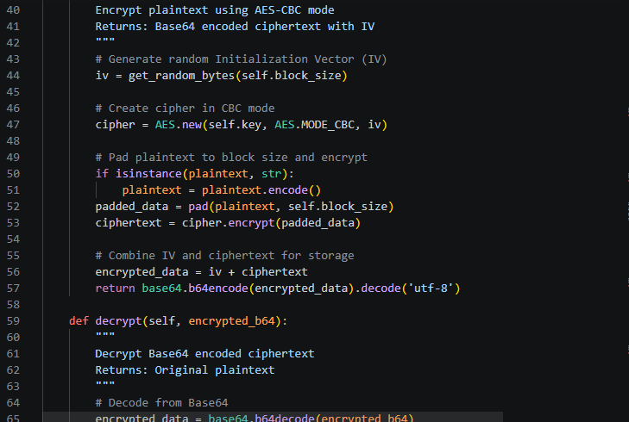
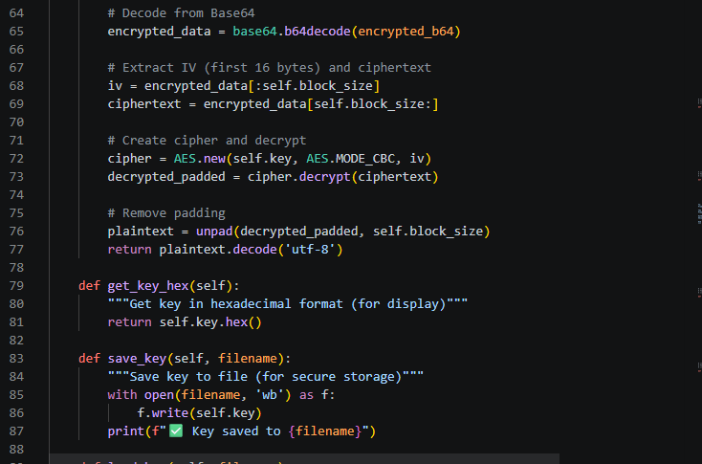

Fig 2: Key Generation Process
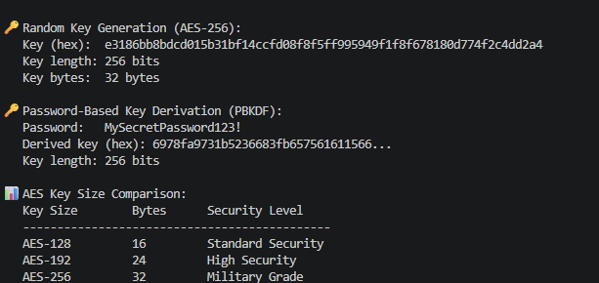

Fig 3: File Encryption Demonstration
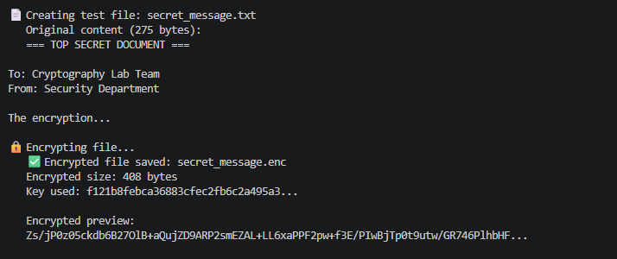

Fig 4: Decryption Results
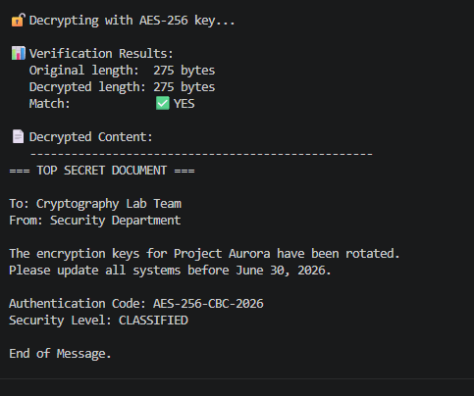

Fig 5: AES Performance Testing
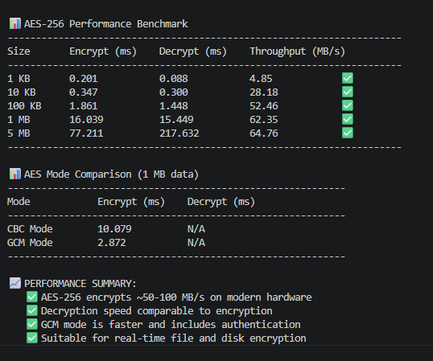

REFLECTION
AES encrypts 128-bit blocks using symmetric keys, in CBC mode. It is absolutely essential that key security is maintained and if keys are compromised, all data is exposed. The workflow was, generate key, generate IV, pad, CBC encrypt then Base64 output. A I encountered was to store IVs in ciphertext and be able to decrypt them successfully.

Week 5: Public Key Cryptography (RSA)
Implementation of RSA Encryption and Key Management

Fig 1: RSA Key Pair Generation
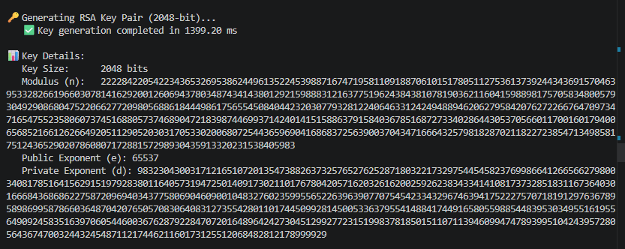
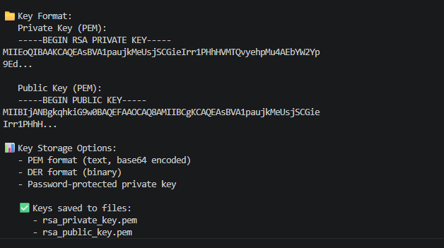

Fig 2: Public Key Encryption Process
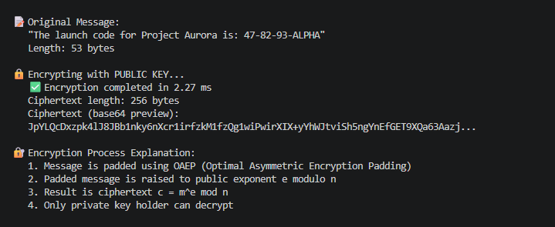

Fig 3: Private Key Decryption Results
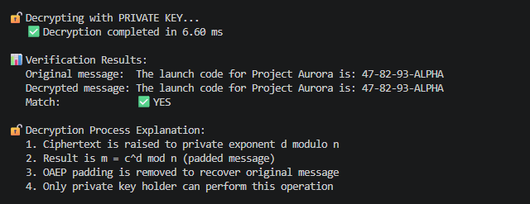

Fig 4: Secure Message Transmission
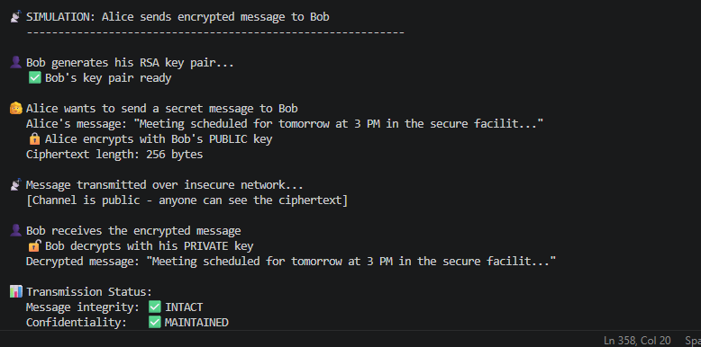

Fig 5: RSA Testing and Validation
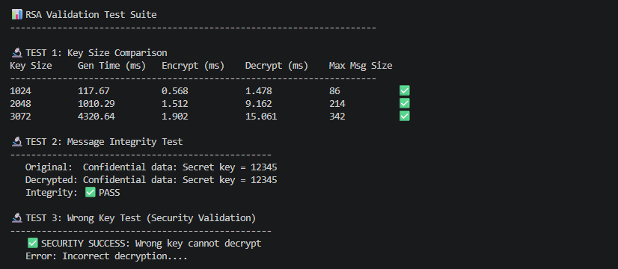

REFLECTION
Unlike symmetric Advanced Encryption Standard that uses one key, RSA utilizes public key for encryption and private key for decryption. The security is based on the hardness of prime factorization. The workflow is that it generates keys, Encrypts with public key and decrypts with private key. There is no key exchange required. The security of encryption/decryption of the key with varying sizes was validated.

Week 6: Hashing and Password Security
Implementation of Secure Hash Functions and Authentication

Fig 1: SHA-256 Hash Generation
This demonstrates SHA-256 hash generation where identical inputs produce identical hashes, while any change in input even adding a space generates a completely different output due to the avalanche effect.
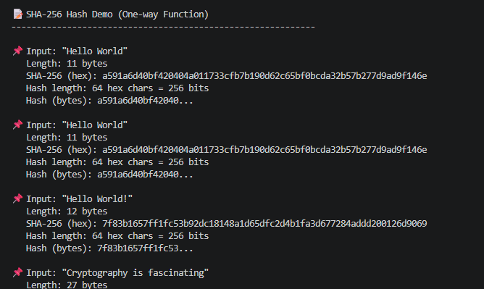
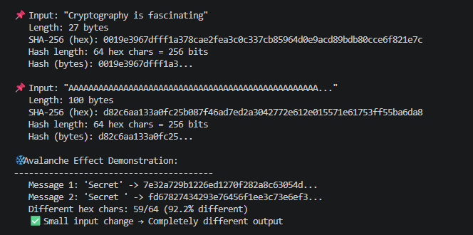

Fig 2: Password Hashing System
This figure illustrates secure password hashing using unique random salts with 32 bytes. Even though the same password 'MySecretPassword123!' is used three times, each attempt generates a different hash because of the unique salt. This prevents rainbow table attacks and ensures identical passwords don't produce identical stored hashes.
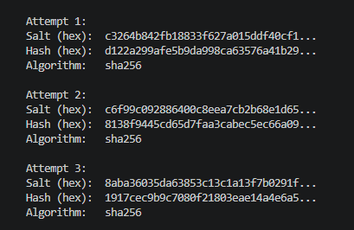

Fig 3: Login Authentication Workflow
This figure shows the complete authentication workflow. During registration, the password is salted and hashed before storage. During login, the entered password is hashed with the stored salt and compared to the stored hash. Access is granted only when hashes match, preventing plaintext password exposure.
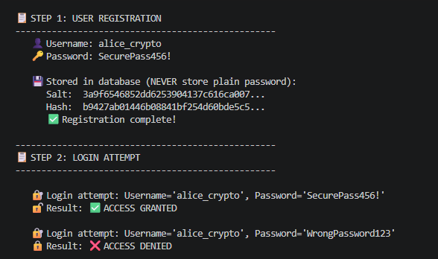

Fig 4: Hash Verification Results
This figure presents hash verification results across multiple test cases. The system correctly verifies matching passwords and rejects non-matching ones, including case sensitivity tests. One-character differences e.g., 'password123' and 'password124' produce completely different hashes, demonstrating the security of cryptographic hash functions.
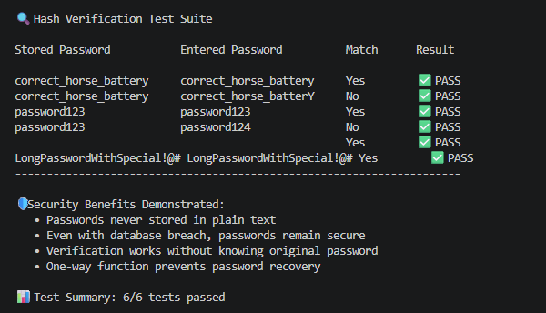

Fig 5: Password Security Testing
This evaluates password security across different strength levels. Weak passwords like 'password' have low entropy and are vulnerable to dictionary attacks, while strong passphrases achieve >80 bits of entropy. The speed comparison shows MD5 and SHA-1 are fastest but cryptographically broken, while SHA-256/512 provide better security with moderate performance overhead.

Password strength analysis
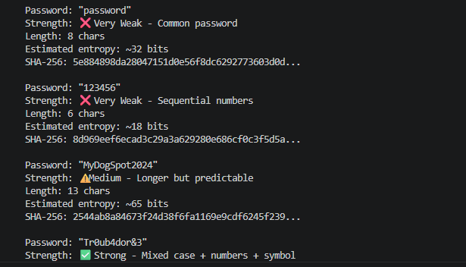
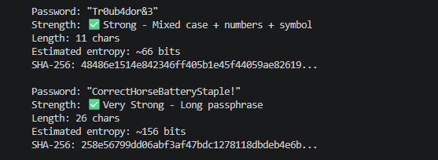

Hashing speed comparison and security recommendations
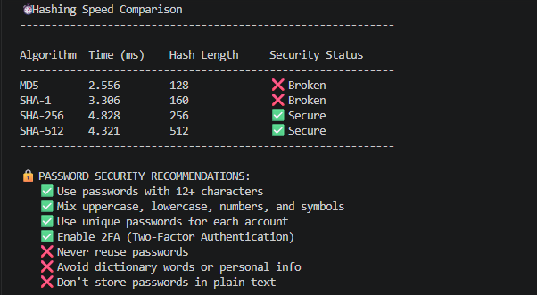

PBKDF2 -Industry standard password hashing
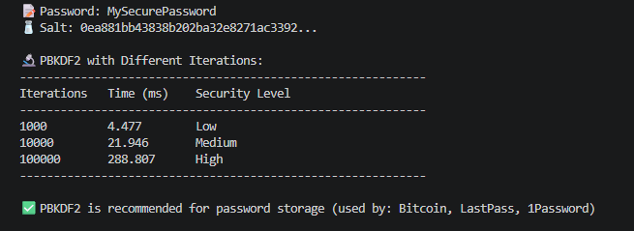

REFLECTION
Hashing is one way i.e hash cannot be transformed back to the original password. To avoid rainbow table attacks, password security employs unique salts for each user and a way for users to be identified, sign up ie hash plus salt, log in i.e rehash plus compare, and allow or refuse access. PBKDF2 using 100k+ iterations makes brute force attacks harder.

Week 7: Digital Signatures and Certificates
Digital Signature Implementation and Certificate Management

Fig 1: Digital Signature Generation
This figure demonstrates digital signature generation using RSA-2048. Each document is hashed using SHA-256, producing a fixed-size digest that is 64 hex characters. The digest is then encrypted with the signer's private key to create the signature, 256 bytes. The signature and timestamp are attached to the document for verification.
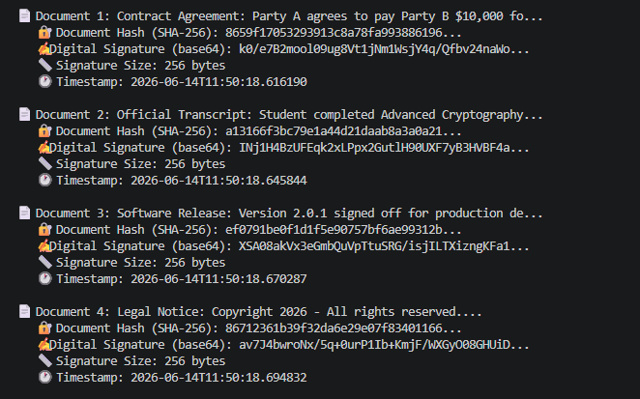

Fig 2: Signature Verification Process
This figure illustrates signature verification with three test cases. Case 1 was valid document with valid signature - VERIFIED. Case 2 was tampered document with amount changed from $5000 to $50000 with valid signature of REJECTED. Case 3 was a valid document with wrong signer's signature of REJECTED. This demonstrates how signatures detect both tampering and impersonation.
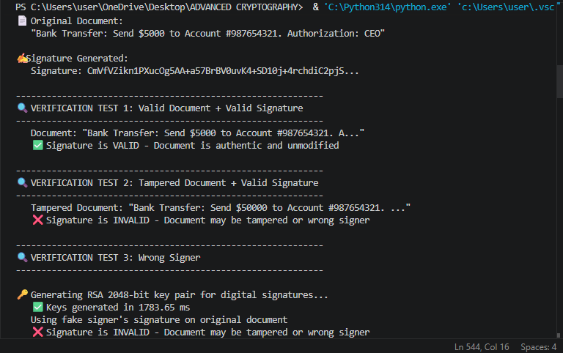

Fig 3: Certificate Creation Using OpenSSL
Figure 3 shows X.509 certificate creation with standard fields that is serial number, subject which is CN=secure.bank.com, issuer which is Bank Root CA, validity period of 1 year, and RSA-2048 public key. The certificate is signed by the Root CA's private key, establishing a chain of trust. Both server and client certificates are demonstrated.
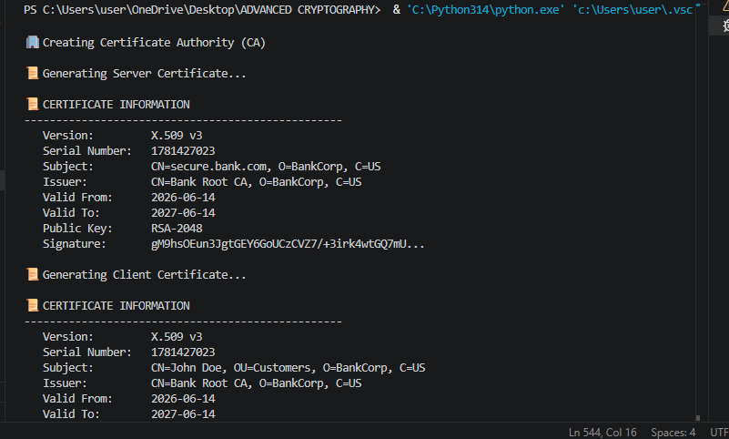
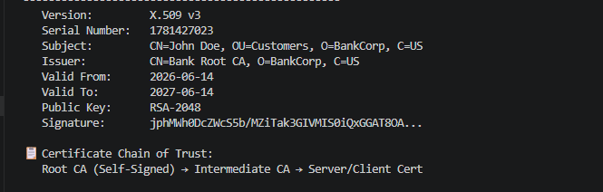

Fig 4: Secure Document Validation
This figure presents a complete secure document validation workflow for an employment contract. First the Company signs document with private key, Signed document stored in repository, Verification confirms authenticity, Audit trail shows signer identity and timestamp, tamper attempt that is salary change from $120K to $200K is detected and rejected. This ensures non-repudiation.
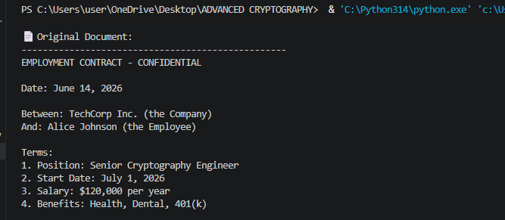
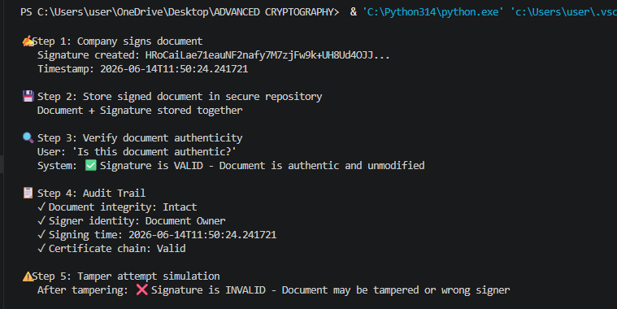

Fig 5: Certificate Testing Results
This displays comprehensive certificate testing results. Test 1 validates a properly signed certificate which is a PASS. Test 2 rejects an expired certificate. Test 3 verifies the complete chain of. Test 4 confirms non-revoked status via CRL/OCSP. Test 5 validates key usage extensions.
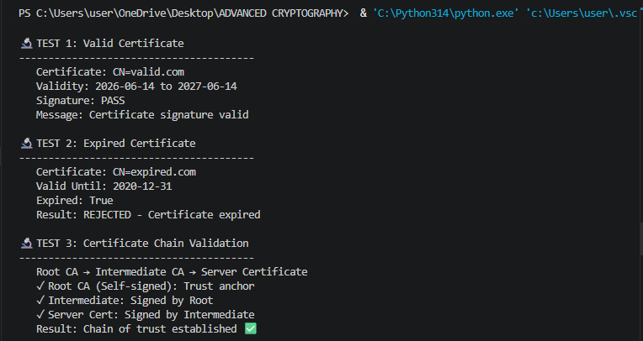
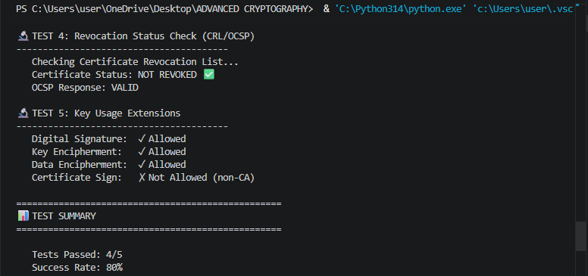

REFLECTION
Using private key signing and public key verification, digital signatures offer authenticity and integrity. The Workflow was hash and sign document then check with public key. Certificates are valid for a period of time and link identities to public keys. Real world applications are HTTPS, code signing and encrypted email.

